***­***

***It Didn't Start With You* by Mark Wolynn**

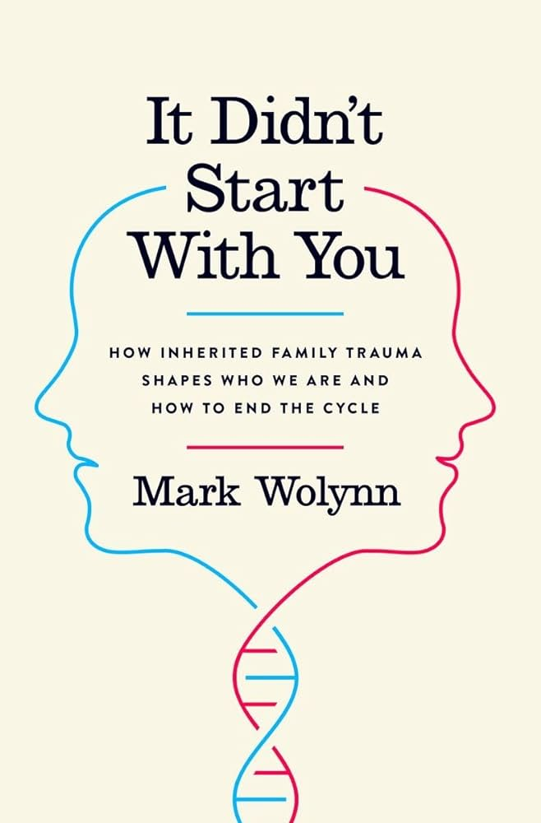

**How Inherited Family Trauma Shapes Who We Are**

**and How to End the Cycle**

**Summary:**

Mark Wolynn's *It Didn't Start With You* delves into the concept of inherited family trauma, exploring how the unresolved emotional wounds of our ancestors can manifest in our lives as anxiety, depression, chronic pain, and other challenges. Drawing on research in epigenetics and neuroscience, Wolynn introduces the Core Language Approach—a method to identify and heal these inherited traumas by uncovering the emotionally charged language and patterns that connect us to our family's past.

**Key Takeaways:**

* **Inherited Trauma:** Trauma can be transmitted across generations, influencing our behaviors and health even if we are unaware of its origins.
* **Epigenetic Evidence:** Studies show that traumatic experiences can alter gene expression, affecting descendants' stress responses and emotional well-being.
* **Core Language Approach:** By identifying recurring phrases and emotional patterns, individuals can trace current issues back to familial traumas.
* **Genograms:** Creating detailed family trees helps map out generational patterns and uncover hidden traumas.
* **Healing Practices:** Techniques such as visualization, mindfulness, and "healing sentences" can aid in resolving inherited emotional wounds.
* **Breaking the Cycle:** Awareness and intentional healing can disrupt the transmission of trauma, fostering healthier relationships and personal growth.